EX 12 PL/SQL TRIGGERS

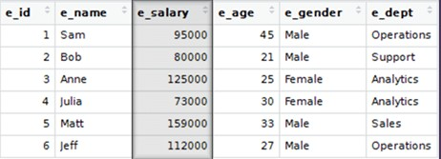

Create a row-level trigger for the EMPLOYEE table that would get executed by the DML statement like UPDATE OR INSERT on that table.

The trigger will compute and show the SALARY difference between current and previous values.(Hint: previous salary: , current salary: , salary difference: )

create table emp(e_id int,e_name varchar(20),e_salary int,e_age int,e_gender varchar(20),e_dept varchar(20));

insert into emp values(1,'Sam',95000,45,'Male','Operations');

insert into emp values(2,'Bob',80000,21,'Male','Support');

insert into emp values(3,'Anne',125000,25,'Female','Analytics');

insert into emp values(4,'Julia',73000,30,'Female','Analytics');

insert into emp values(5,'Matt',159000,33,'Male','Sales');

insert into emp values(6,'Jeff',112000,27,'Male','Operations');

CREATE OR REPLACE TRIGGER display_salary_changes

BEFORE DELETE OR INSERT OR UPDATE ON emp

FOR EACH ROW

WHEN (NEW.e_id > 0)

DECLARE

sal_diff number;

BEGIN

sal_diff := :NEW.e_salary - :OLD.e_salary;

dbms_output.put_line('Old salary: ' || :OLD.e_salary);

dbms_output.put_line('New salary: ' || :NEW.e_salary);

dbms_output.put_line('Salary difference: ' || sal_diff);

END;

/

UPDATE emp

SET e_salary = e_salary + 1000

WHERE e_id = 2;

INSERT INTO emp VALUES(7,'Ram',100000,44,'Male','Operations');

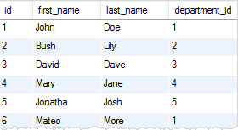

Create a trigger for the STUDENT table that would get executed by the DML statement like UPDATE OR INSERT on that table.

The trigger will compute and show the message “Department does not exist if the department_ id is greater than 5”.

create table student(id int,first_name varchar(20),last_name varchar(20),department_id int);

insert into student values(1,'Josh','Doe',1);

insert into student values(2,'Bush','Lily',2);

insert into student values(3,'David','Dave',3);

insert into student values(4,'Mary','jane',4);

insert into student values(5,'Jonatha','Josh',5);

insert into student values(6,'Mateo','More',1);

CREATE OR REPLACE TRIGGER id_war

BEFORE DELETE OR INSERT OR UPDATE ON student

FOR EACH ROW

WHEN(NEW.department_id>5)

BEGIN

DBMS_OUTPUT.PUT_LINE('Department does not exist if the department_ id is greater than 5');

END;

/

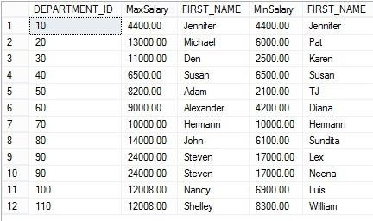

Create a trigger for the EMPLOYEE table that would get executed by the DML statement like UPDATE OR INSERT on that table.

The trigger will compute and show the difference between the min salary and max salary.